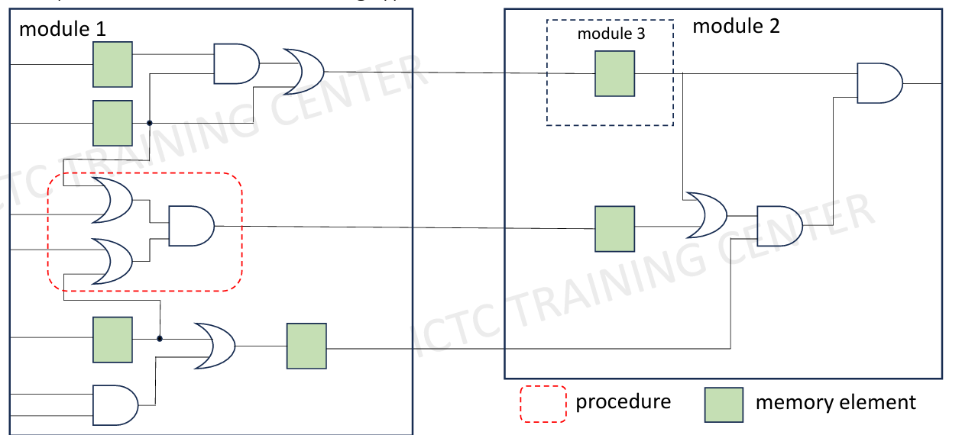
Homework 1:
reg
reg
reg
reg
reg
wire
reg
reg
reg
reg
reg
reg
reg
reg
reg
reg
wire
wire
wire
wire
wire
wire
wire
wire
wire
wire
wire
wire
wire
wire
wire
wire
wire

Homework 2:
